Physics 106  General Physics | April 24, 2009  Test 3

Show work. Include units. Provide reasoning. Say what you would do even if you do not have all of the necessary information (e.g. the answer from another part).
+
-
-
-
1. The arrangement of charges shown above includes a charge of -2mC at (-1.5, 0); a charge of +4mC at (0, 0); and a charge of -2mC at (1.5, 0).
where distances are measured in centimeters.
- Draw the electric field lines for this charge arrangement.
- Draw a surface that has a net positive electric flux.
- Calculate the electric field (magnitude and direction) at (0.5, 0).
- Calculate the electric potential experienced by the charge at (-1.5, 0).
- How much energy would be required to take that charge infinitely far away?

2. For the RC circuit shown above determine the following
A. The initial current when the switch is flipped to connect the battery into the circuit.
B. The charge that leaves the battery after a long time.
C. The voltage across the 1.1-µF after a long time.
D. The time for 90% of the ultimate charge to be reached.
E. Which is longer a) the time to charge up to 90% of the ultimate charge or b) the time to lose 90% of its charge when the switch is flipped back? Explain.

3. For the circuit shown above determine the following
A. The currents flowing through the 2.4-kΩ,
B. The current flowing through the 4.7-kΩ
C. The voltage across the 2.2-kΩ resistors.

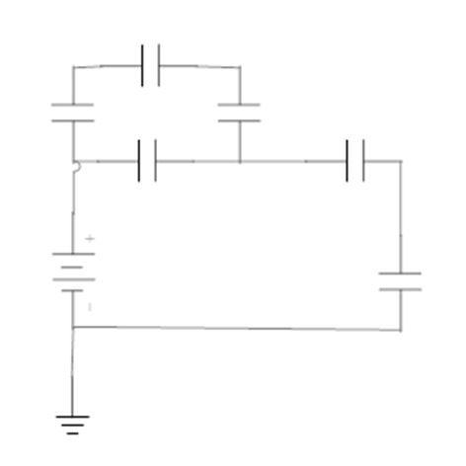
12 V
1.2 μF
1.2 μF
2.3 μF
3.4 μF
4.5 μF
5.6 μF
6.7 μF

4. For the capacitor circuit shown above, determine the following
A. The equivalent capacitance
B. The charge on the 5.6-μF capacitor
C. The charge on the 1.2-μF capacitor
D. The voltage across the 6.7-μF capacitor.

